Phuc Hong Le

CSS 342

Professor Ahmed Awad

November 11, 2017

**Assignment 3 Documentation**

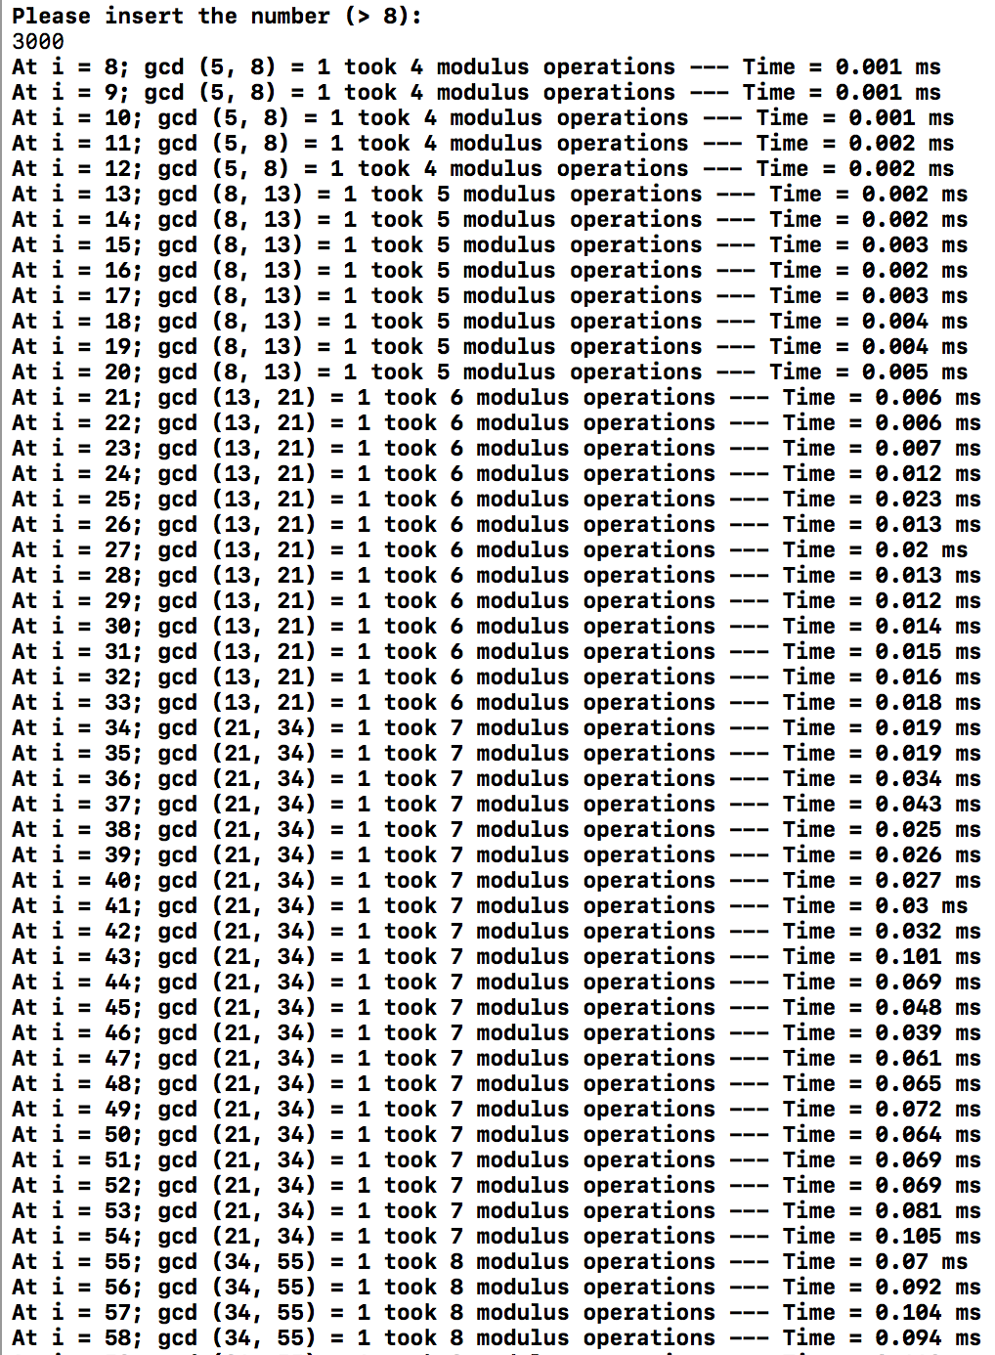The output of the program Euclid.cpp:

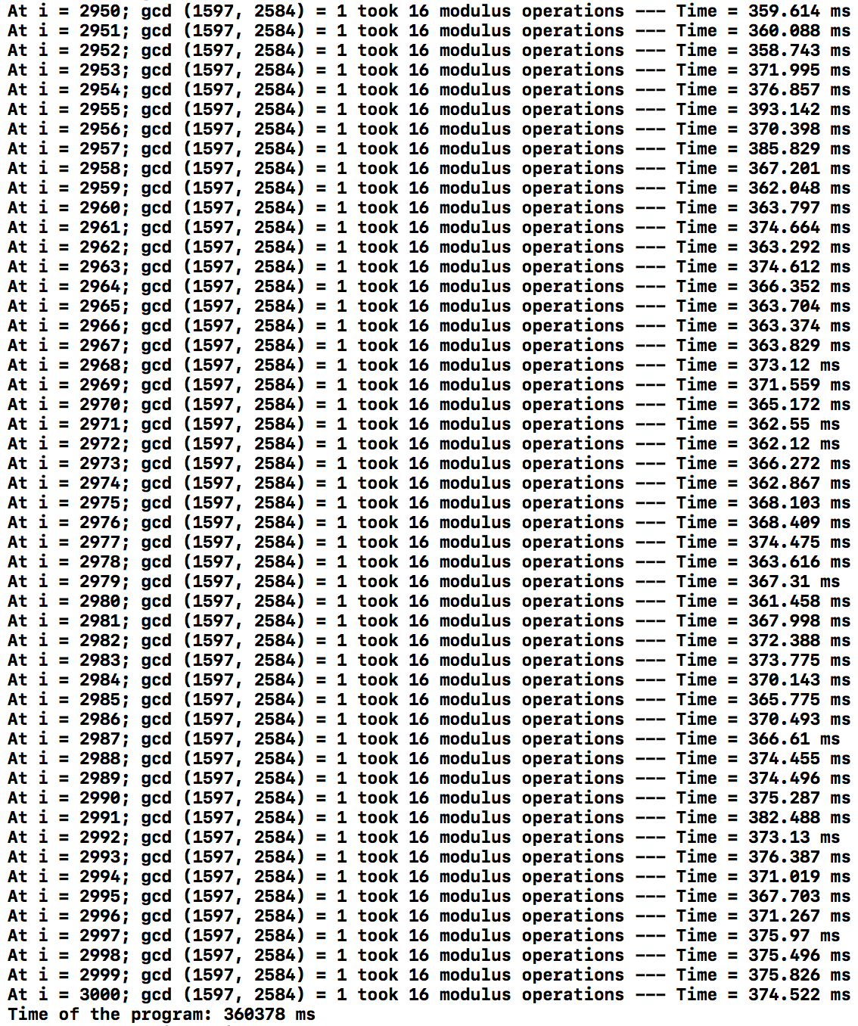

The graph of maximum number of modules operations:

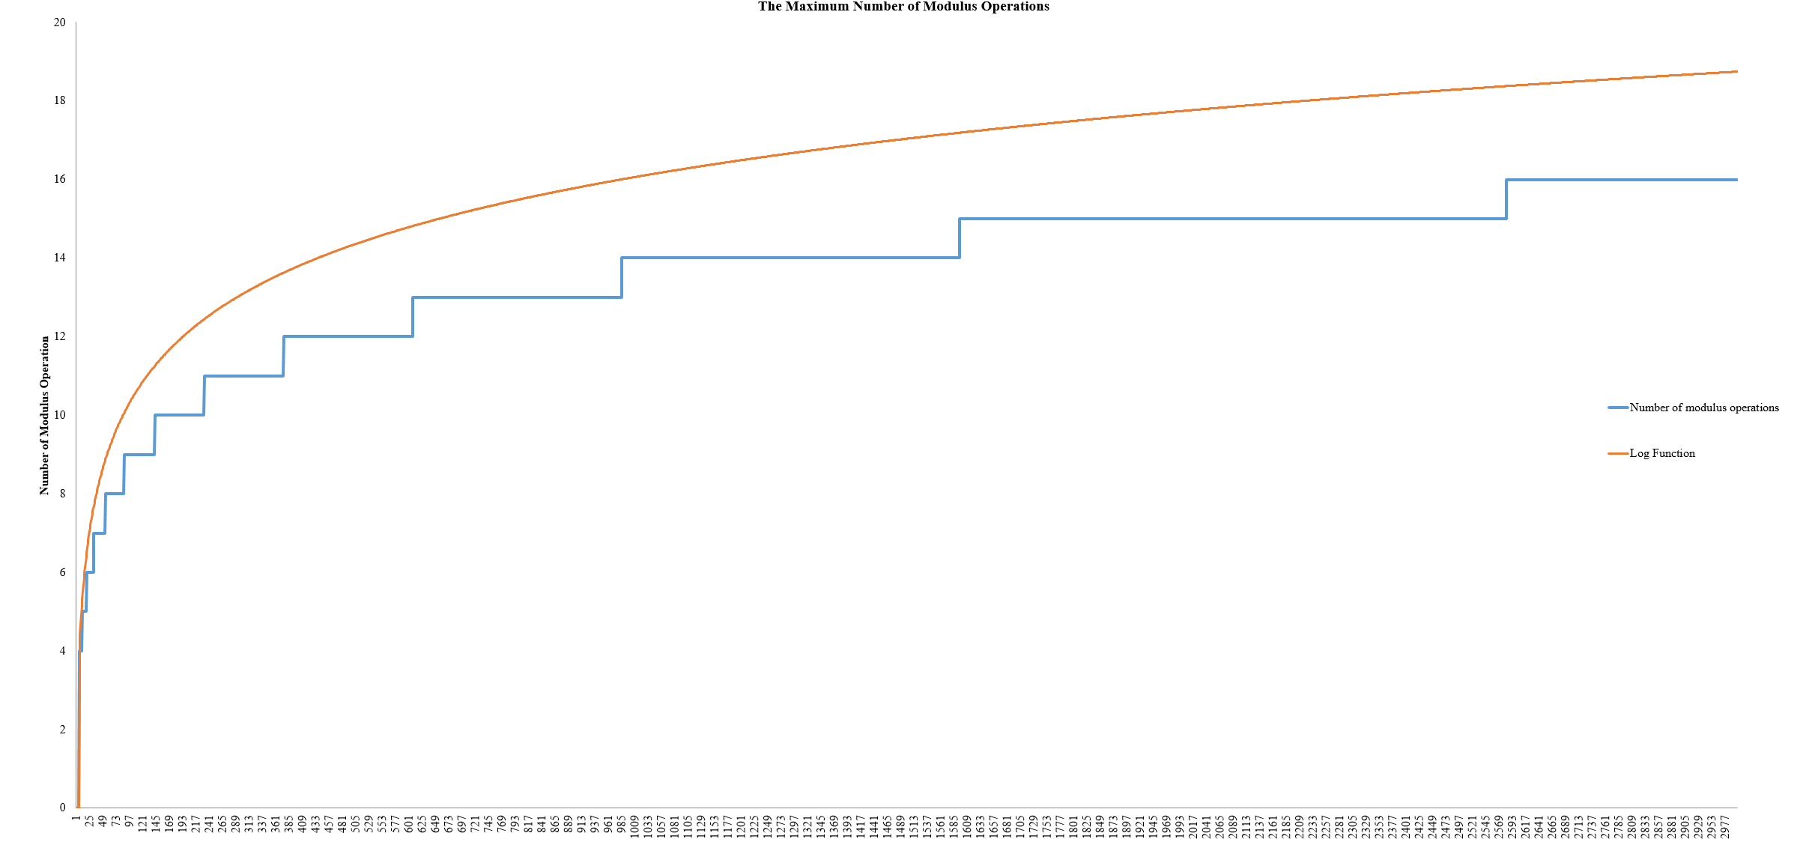

The graph above is plotted with all 3000-data gained from the compiler.

The **Orange** line presents the log function upon each individual number of n.

The **Blue** line presents the number of modulus operations

The graph of the Big-O estimation for the program T(n), F(n), and T(n) / F(n):

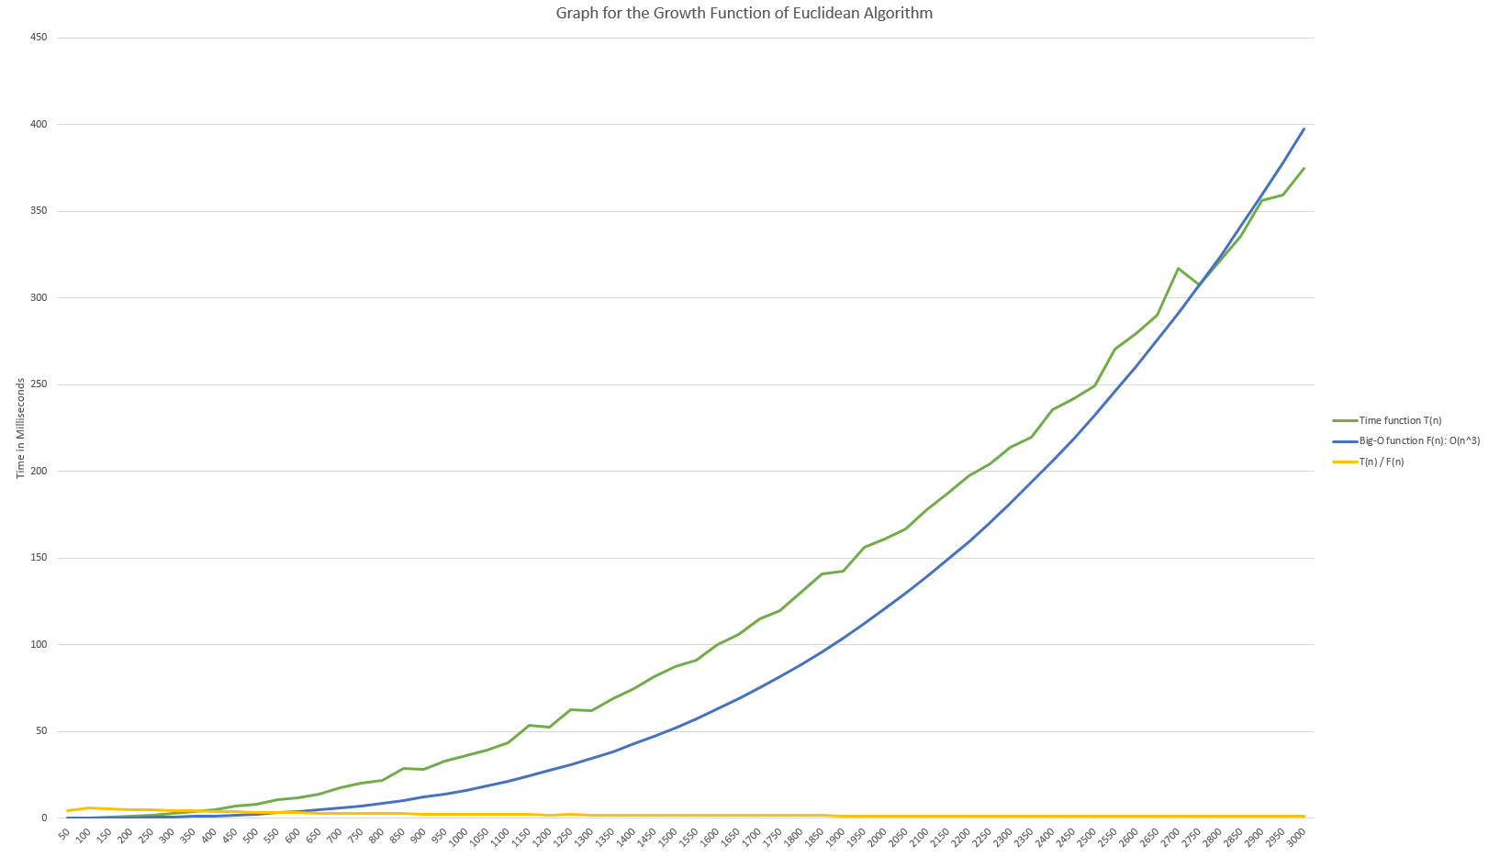

The graph above is graphed from 60 data points out of 3000. This is varied from n = 50, 100, 150, 200, and until it reaches 3000. The graph is represented in milliseconds for the time function. My estimation is considered correct as the number of T(n) / F(n) is fluctuated to a specific constant without increasing as n get bigger.

The **Green** line presents the Time Function T(n).

The **Blue** line presents the estimation of Big-O Function F(n).

The **Orange** line presents the division of T(n) and F(n).

From the graph, I estimate that the Time function T(n) is O(n^3). Therefore, the estimation Big-O Function F(n) is O(n^3). In order to make the Big-O function smaller, I multiplied the O(n^3) with a constant of 0.00175.

The following table 1 will show all the data from the Big-O of T(n), F(n), and T(n) / F(n) as n increases:

Table 1. Data analysis of the growth functions of the program (Euclidean Algorithm):

